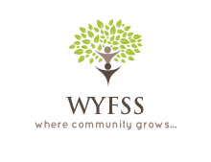

**Willington Youth, Family and Social Services**

40 Old Farms Road, Willington, Connecticut 06279

(860)487-3118 ☼ wyfss@willingtonct.org

Youth Services Advisory Board

Meeting Agenda

Willington Town Office Building, Lower Level Conference Room

Wednesday July 22, 2015 at 1:00 p.m.

CALL TO ORDER

List of area Resources

questions for Parks and Recreation Commission  
  
Discussion of Proposed State Police Gun range

ADJOURNMENT