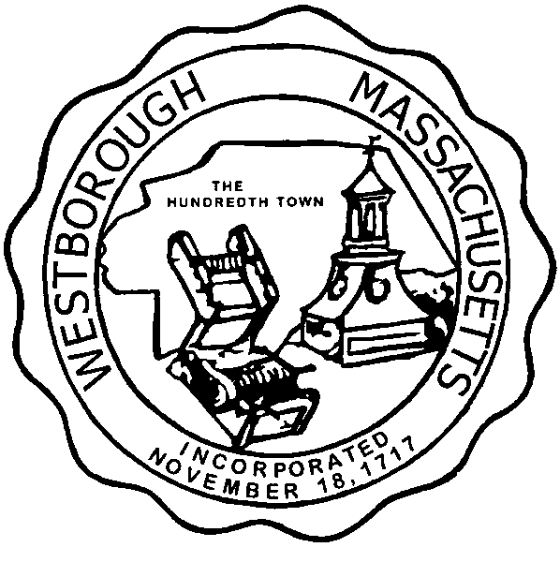

TOWN OF WESTBOROUGH

MASSACHUSETTS

Conservation Commission

Forbes Municipal Building 45 West Main St.

Westborough, MA 01581

(508) 366-3014

October 14, 2016

Ms. Wendy Mickel

Town Clerk

Westborough Town Hall

Westborough, MA 01581

Dear Wendy,

This Conservation Commission will meet on Monday, October 17, 2016 at 6:30PM for the Special Town Meeting at the Westborough High School Auditorium, 90 West Main Street, Westborough, MA. The Commission will recess and adjourn in conjunction with Town Meeting.

Respectfully Submitted,

Sheri Rullie