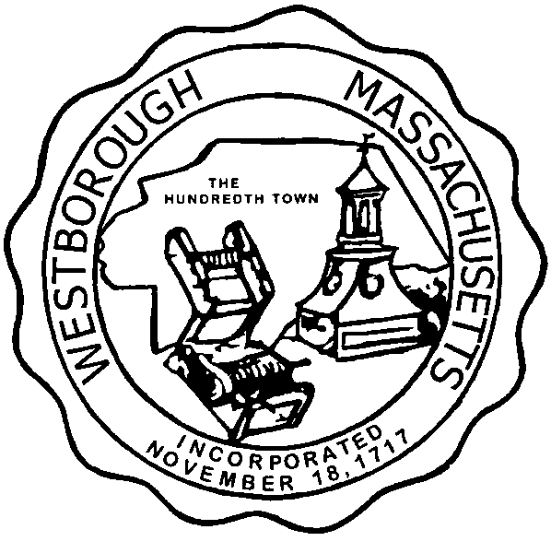

TOWN OF WESTBOROUGH

MASSACHUSETTS

Conservation Commission

Forbes Municipal Building 45 West Main St.

Westborough, MA 01581

(508) 366-3014

October 14, 2016

Ms. Wendy Mickel

Town Clerk

Westborough Town Hall

Westborough, MA 01581

Dear Wendy,

This is to inform you that the Westborough Community Land Trust will be hosting a hike of the Sandra Pond Watershed on Sunday, October 16, 2016 starting at 1:30PM at the Minutemen Man Park off Upton Road. The hike is being posted in the event that a quorum is present of Conservation Commission members and the possibility that questions could be asked of the Commission based upon activities conducted within the Watershed. The hike is from 1:30pm to approximately 4:00PM.

Respectfully Submitted,

Sheri Rullie