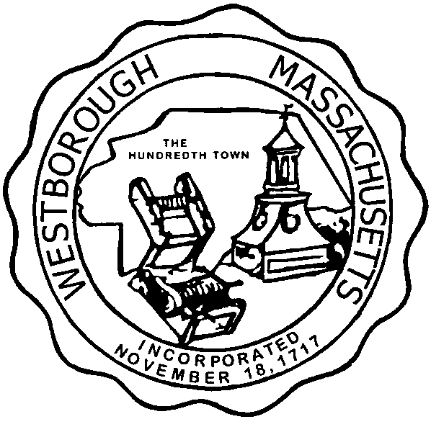

TOWN OF WESTBOROUGH

MASSACHUSETTS

Conservation Commission

Forbes Municipal Building 45 West Main St.

Westborough, MA 01581

(508) 366-3014

February 5, 2016

Ms. Wendy Mickel

Town Clerk

Westborough Town Hall

Westborough, MA 01581

Dear Wendy,

This is to inform you that the Conservation Commission will hold a meeting on Tuesday**,** February 9, 2016 at the Forbes Municipal Building, 45 West Main Street, 2nd Floor Room 23, beginning at 7:00 p.m. This is the agenda for that meeting:

7:00pm – Hearing – Request for Determination of Applicability – Kearsarge Solar, LLC located at 238 Turnpike Road (Town of Westborough Wastewater Treatment Facility).

7:15pm – Hearing – Notice of Intent – Cumberland Farms, Inc, 165 Flanders Road.

7:30pm – Discussion – Carmax Wetland Planting Mitigation Modification located at 170 Turnpike Road.

7:45pm – Discussion – Update on Sandra Pond Reservoir Watershed Activities.

Other Business:

Extension Permit DEP File# 332-757 Exxon Mobil, Mass Turnpike Rest Area 6AW

Extension Permit DEP File# 332-842 Cumberland Farms, 165 Flanders Road

Partial Certificate of Compliance DEP File# 332-843, 346 Turnpike Road

Conservation Officer Updates

Other updates will be given at the meeting.

Respectfully Submitted,

Sheri Brown

Administrative Assistant