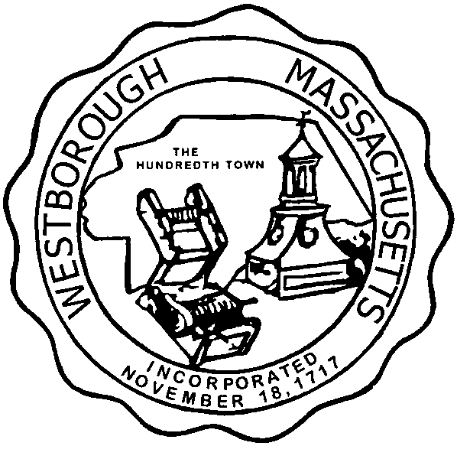

TOWN OF WESTBOROUGH

MASSACHUSETTS

Conservation Commission

Forbes Municipal Building 45 West Main St.

Westborough, MA 01581

(508) 366-3014

January 7, 2016

Ms. Wendy Mickel

Town Clerk

Westborough Town Hall

Westborough, MA 01581

Dear Wendy,

This is to inform you that the Conservation Commission will hold a meeting on Tuesday**,** January 12, 2016 at the Forbes Municipal Building, 45 West Main Street, 2nd Floor Room 23, beginning at 7:00 p.m. This is the agenda for that meeting:

7:00pm – Hearing – Notice of Intent filed by Westborough Department of Public Works for the rehabilitation of two existing sewer pump stations located at 119 Flanders Road and adjacent to 165 Flanders Road.

7:15pm – Discussion – Year-End Review of the Conservation Officer’s 2015 Goals.

7:25pm – Discussion – Conservation Officer’s 2016 Goals.

Other Business:

Conservation Officer Updates

Other updates will be given at the meeting.

Respectfully Submitted,

Sheri Brown

Administrative Assistant