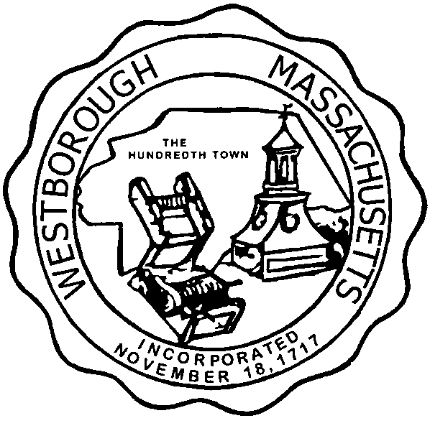

TOWN OF WESTBOROUGH

MASSACHUSETTS

Conservation Commission

Forbes Municipal Building 45 West Main St.

Westborough, MA 01581

(508) 366-3014

December 3, 2015

Ms. Wendy Mickel

Town Clerk

Westborough Town Hall

Westborough, MA 01581

Dear Wendy,

This is to inform you that the Conservation Commission will hold a meeting on Tuesday**,** December 8, 2015 at the Forbes Municipal Building, 45 West Main Street, 2nd Floor, Room 23 beginning at 7:00 p.m. This is the agenda for that meeting:

7:00pm –Hearing – Request for Determination of Applicability filed by Well-Being Center, LLC and Five Partners, LLC at 146 & 148 Oak Street.

7:20pm – Discussion- Removal of dead Red Pine trees near the Sandra Pond Lower Reservoir.

Other Business:

Full Certificate of Compliance DEP File 332-824, 24 Nourse Street.

Conservation Officer Updates

Other updates will be given at the meeting.

Respectfully Submitted,

Sheri Brown

Administrative Assistant