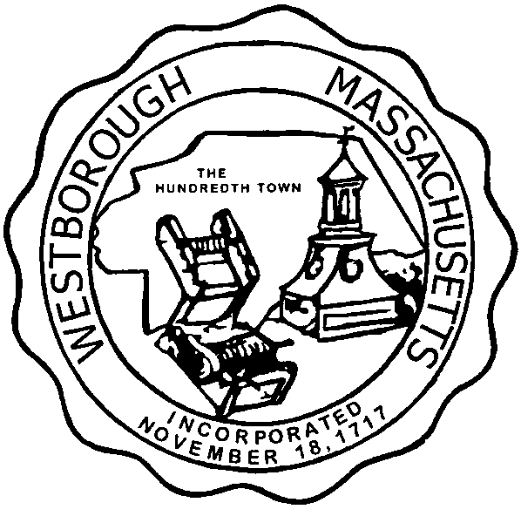

TOWN OF WESTBOROUGH

MASSACHUSETTS

Conservation Commission

Forbes Municipal Building 45 West Main St.

Westborough, MA 01581

(508) 366-3014

October 6, 2015

Ms. Wendy Mickel

Town Clerk

Westborough Town Hall

Westborough, MA 01581

Dear Wendy,

This is to inform you that the Conservation Commission will hold a meeting on Tuesday**,** October 13, 2015 at the Westborough Senior Center Meeting Room located at 4 Rogers Road, beginning at 6:45p.m. This is the agenda for that meeting:

6:45p.m. – Discussion- Gail Smith horse trails at the Libbey Conservation Area off Adams Street.

6:50p.m. –Discussion– Exxon Mobil Rest Area 6AW remediation efforts.

7:15p.m. –Hearing – Notice of Intent- Jeffrey & Jessica Lusek 24 Old Colony Drive.

7:30p.m.-Hearing- Abbreviated Notice of Resource Area Delineation-Mass. Department of Transportation Highway Division, parcels of land surrounding Route 495/Route 90 interchange.

Other Business:

Full Certificate of Compliance DEP File 332-853, Warren Street

Full Certificate of Compliance DEP File 332-862, 1 Olde Hickory Path

Chauncy parking lot proposed tennis court.

Conservation Officer Updates

Other updates will be given at the meeting.

Respectfully Submitted,

Sheri Brown

Administrative Assistant