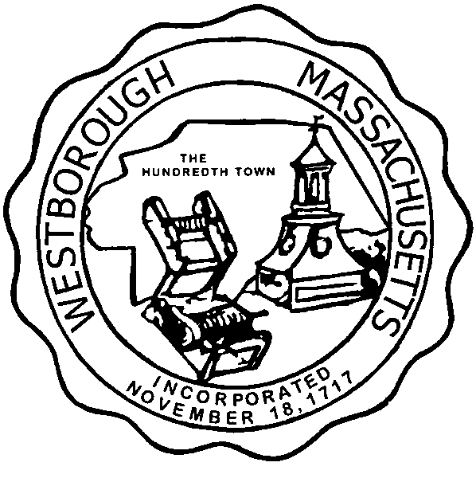

TOWN OF WESTBOROUGH

MASSACHUSETTS

Conservation Commission

Forbes Municipal Building 45 West Main St.

Westborough, MA 01581

(508) 366-3014

August 6, 2015

Ms. Wendy Mickel

Town Clerk

Westborough Town Hall

Westborough, MA 01581

Dear Wendy,

This is to inform you that the Conservation Commission will hold a meeting on TuesdayAugust 11, 2015 at the Westborough Senior Center Meeting Room located at 4 Rogers Road, beginning at 7:00 p.m. This is the agenda for that meeting:

7:00pm –Discussion- Bicycle easement over Carmaxs’ property

7:15pm – Discussion – Draft 10-Year Forest Management Plan for lands abutting Sandra Pond Reservoir.

7:30pm – Discussion – Update I-90/I-495 Improvement Project

Other Business:

Full Certificate of Compliance for DEP File #332-378 located off Piccadilly Way

Full Certificate of Compliance for DEP File #332-848 located at 10 Phylmor Drive

Extension Permit for DEP File #332-790 located at 238 Turnpike Road

Approve Meeting Minutes

Conservation Officer Updates

Other updates will be given at the meeting.

Respectfully Submitted,

Sheri Brown