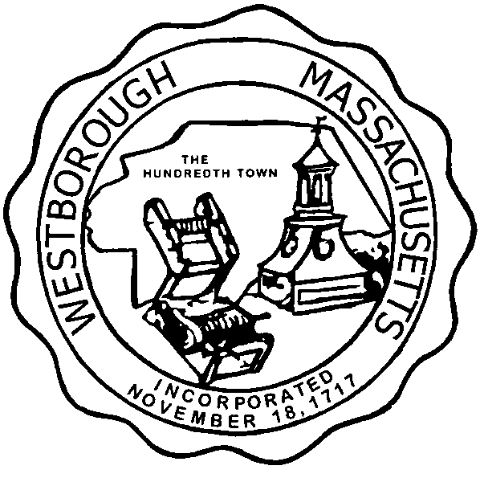

TOWN OF WESTBOROUGH

MASSACHUSETTS

Conservation Commission

Forbes Municipal Building 45 West Main St.

Westborough, MA 01581

(508) 366-3014

July 8, 2015

Ms. Wendy Mickel

Town Clerk

Westborough Town Hall

Westborough, MA 01581

Dear Wendy,

This is to inform you that the Conservation Commission will hold a meeting on TuesdayJuly 14, 2015 at the Westborough Senior Center Meeting Room located at 4 Rogers Road, beginning at 7:00 p.m. This is the agenda for that meeting:

7:00pm –Discussion- Feirm Crotty, LLC, Glen Street, Map 13, Parcel 193 and Map 13, Parcel 1

7:15pm – Discussion – Bicycle easement over Carmaxs’ property

7:45pm – Discussion – Mid-year evaluation of the Conservation Officer’s 2015 Goals

Other Business:

Approve Meeting Minutes

Conservation Officer Updates

Other updates will be given at the meeting.

Respectfully Submitted,

Sheri Brown

Administrative Assistant