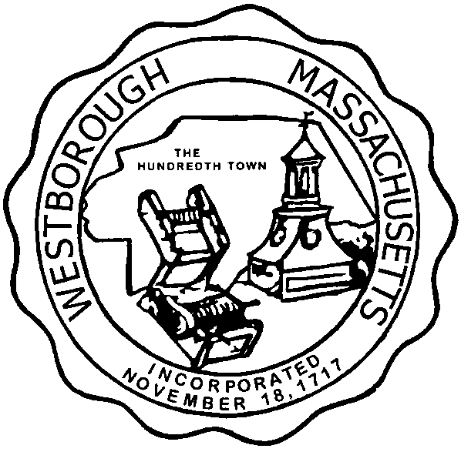

TOWN OF WESTBOROUGH

MASSACHUSETTS

Conservation Commission

Forbes Municipal Building 45 West Main St.

Westborough, MA 01581

(508) 366-3014

June 4, 2015

Ms. Wendy Mickel

Town Clerk

Westborough Town Hall

Westborough, MA 01581

Dear Wendy,

This is to inform you that the Conservation Commission will hold a meeting on TuesdayJune 9, 2015 at the Westborough Senior Center Meeting Room located at 4 Rogers Road, beginning at 7:00 p.m. This is the agenda for that meeting:

7:00pm –Hearing – Notice of Intent filed by Solar City at 25 Research Drive

7:15pm – Discussion – Gary Dufresne 81 East Main Street

7:30pm – Discussion – Paul Latraverse 72 Lyman Street

7:45pm – Discussion – Reservoir Forestry Update

Other Business:

Approve Meeting Minutes

Conservation Officer Updates

Other updates will be given at the meeting.

Respectfully Submitted,

Sheri Brown

Administrative Assistant