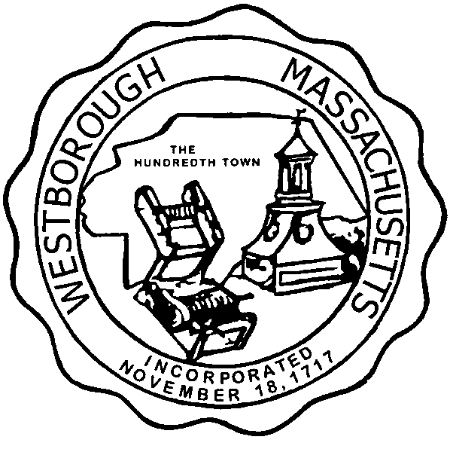

TOWN OF WESTBOROUGH

MASSACHUSETTS

Conservation Commission

Forbes Municipal Building 45 West Main St.

Westborough, MA 01581

(508) 366-3014

November 13, 2014

Ms. Wendy Mickel

Town Clerk

Westborough Town Hall

Westborough, MA 01581

Dear Wendy,

This is to inform you that the Conservation Commission will hold a meeting on Tuesday, November 18, 2014 at the Westborough Senior Center Meeting Room located at 4 Rogers Road, beginning at 7:00 P.M. This is the agenda for that meeting:

7:00 PM – Hearing- Request for Determination of Applicability – Matt Smith 45 Belknap Street.

7:15PM – Discussion – Endorse Conservation Restriction Application Form for CarMax Auto Superstores, Inc. located at 170 Turnpike Road.

7:20 PM – Discussion – Citizen Leadership Academy

Other Business:

Full Certificate of Compliance DEP File 332-56, 50 Otis Street

Full Certificate of Compliance DEP File 332-127, 50 Otis Street

Full Certificate of Compliance DEP File 332-347, 50 Otis Street

Full Certificate of Compliance DEP File 332-238, Ruggles Pond Road

Full Certificate of Compliance DEP File 332-358, 5 Ruggles Pond Road

Full Certificate of Compliance DEP File 332-387, 50 Otis Street

Full Certificate of Compliance DEP File 332-726, 50 Otis Street

Approval of Minutes

Conservation Officer Updates

Report from the Property Inventory Sub-Committee

The Commission may address other business brought before them.

Respectfully Submitted,

Sheri Brown

Administrative Assistant