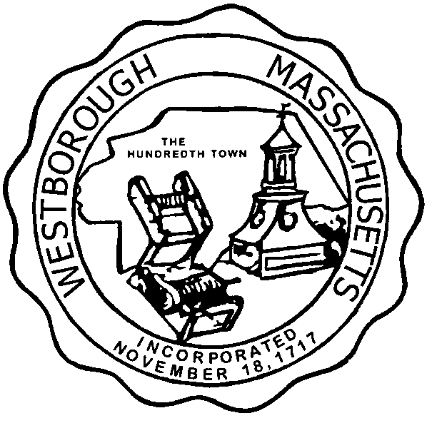

TOWN OF WESTBOROUGH

MASSACHUSETTS

Conservation Commission

Forbes Municipal Building 45 West Main St.

Westborough, MA 01581

(508) 366-3014

October 9, 2014

Ms. Wendy Mickel

Town Clerk

Westborough Town Hall

Westborough, MA 01581

Dear Wendy,

This is to inform you that the Conservation Commission will hold a meeting on Tuesday, October 14, 2014 at the Westborough Senior Center Meeting Room located at 4 Rogers Road, beginning at 7:00 P.M. This is the agenda for that meeting:

7:00 PM – Hearing- Notice of Intent – James N. Ball, 76 & 78 Lyman Street

7:15PM – Worksession – Preservation Acres Subdivision 14-18 Arch Street

7:30 PM – Discussion – Hocomonco Pond potential reuses update.

7:40 PM – Discussion – Revised draft submission protocols.

Other Business:

Full Certificate of Compliance DEP File 332-142, Haskell Street Recreation Field

Full Certificate of Compliance DEP File 332-155, 1400 Computer Drive

Full Certificate of Compliance DEP File 332-201, 2 Rogers Road

Full Certificate of Compliance DEP File 332-224, 18 Nourse Street

Full Certificate of Compliance DEP File 332-335, 1400 Computer Drive

Full Certificate of Compliance DEP File 332-569, 23 Chauncy Cricle

Full Certificate of Compliance DEP File 332-771, 4 O’Neil Drive

Full Certificate of Compliance DEP File 332-846, 290 Turnpike Road

Approval of Minutes

Conservation Officer Updates

Report from the Property Inventory Sub-Committee

The Commission may address other business brought before them.

Respectfully Submitted,

Sheri Brown

Administrative Assistant