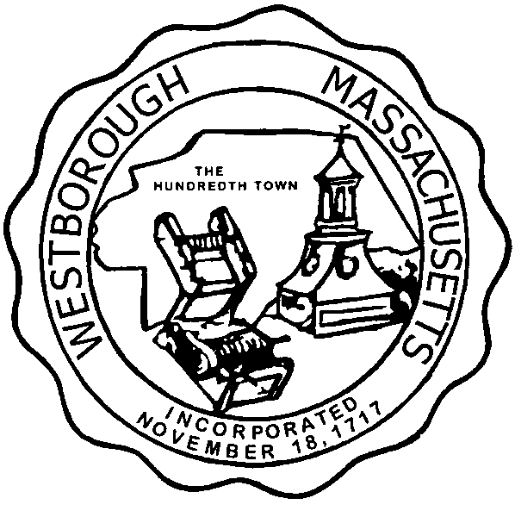

TOWN OF WESTBOROUGH

MASSACHUSETTS

Conservation Commission

Forbes Municipal Building 45 West Main St.

Westborough, MA 01581

(508) 366-3014

July 3, 2014

Ms. Wendy Mickel

Town Clerk

Westborough Town Hall

Westborough, MA 01581

Dear Wendy,

This is to inform you that the Conservation Commission will hold a meeting on Tuesday**,** July 8, 2014 at the Westborough Senior Center Meeting Room located at 4 Rogers Road, beginning at 7:00 p.m. This is the agenda for that meeting:

7:00 PM – Discussion- Exxon Mobile Cleanup at Mass Turnpike Rest Area 6AW and 30 Belknap Street.

7:15 PM – Vote- Chairman and Vice-Chairman

7:20 PM – Discussion – Mid-year review of the Conservation Officer’s 2014 Goals

Other Business:

Approval of Minutes

Conservation Officer Updates

Full Certificate of Compliance DEP File 332-134, Technology Drive

Full Certificate of Compliance DEP File 332-782, Fisher Street Roadway

Extension DEP File 332-783, Water Purification Plant Access Drive

Full Certificate of Compliance DEP File 332-825, 146 Fisher Street

Report from the Property Inventory Sub-Committee

The Commission may address other business brought before them.

Respectfully Submitted,

Sheri Brown

Administrative Assistant