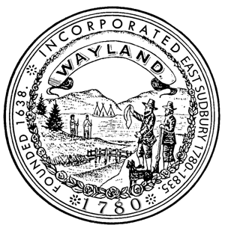

TOWN OF WAYLAND

BOARD OF HEALTH

41 COCHITUATE ROAD

WAYLAND, MASSACHUSETTS 01778

Julia Junghanns, R.S., C.H.O.

DIRECTOR OF PUBLIC HEALTH

TEL. (508) 358-3617

www.wayland.ma.us

**AGENDA – January 3, 2017**

7:00 p.m. Discuss the Recreational Marijuana Law and ATM Article for Temporary Moratorium on Recreational Marijuana Establishments

7:10 p.m. Attend Planning Board meeting to discuss ATM Warrant Article for Temporary Moratorium on Recreational Marijuana Establishments

7:20 p.m. Discuss ATM Warrant Articles; Plastic Check-out bag Bylaw and Polystyrene Food Container Bylaw, Guest: Lead Petitioner, Paul Dale

7:45 p.m. Discuss existing septic systems in Zone I’s of a Public Drinking Well

8:10 p.m. Policy Discussion - Policy on Use of Variances to Support Expansion

8:30 p.m. Policy Discussion - Policy on Use of Active and Passive I&A Technologies

8:45 p.m. General business

* Approve Bills
* Approve minutes – November 2, 2016, November 28, 2016
* Set future meeting dates
* Review Director’s report

9:00 p.m. Topics not reasonably anticipated by the chair 48 hours in advance of the meeting, if any

Next meeting: To be determined

Please note: items may not be discussed in the exact order listed

010317agenda