TOWN OF WAYLAND

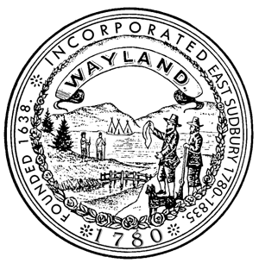

41 COCHITUATE ROAD

WAYLAND, MASSACHUSETTS 01778

Julia Junghanns, R.S., C.H.O.

DIRECTOR OF PUBLIC HEALTH

TEL. (508) 358-3617

www.wayland.ma.us

**BOARD OF HEALTH**

**AGENDA – December 14, 2015**

7:00 p.m. Provide Public Comment to the Board of Selectmen regarding the proposed Mutual Aid Agreement with Sudbury for Public Health Agencies. (BOS consent calendar item)

Next meeting

December 16, 2015

121415agenda