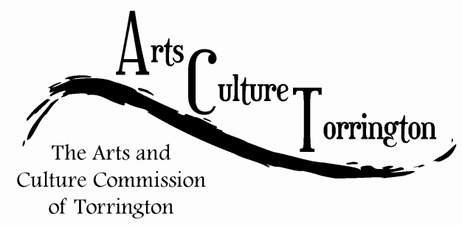

MINUTES
February 24th, 2016| 8:00am | City Hall Auditorium
Attendance: Ed Cannata, Jacque Williams, Bill Haygood, Kim McAllister, Mike McAllister, Marie Soliani, Tim Waldron
The meeting was called to order by Chairman Ed Cannata at 8:03am
Minutes of the January ACT meeting were approved on a motion made by Jacque Williams, seconded by Mike McAllister
Public Comment: There were no members of the public in attendance
Ideas & Initiatives: Marie Soliani suggested that ACT get involved with the Yarn Bombing coming up in June. Bill offered to ask Noel Croce how the commission might be able to get involved.
Bill Haygood asked about movies being sponsored by the ACT Commission. The committee discussed whether our role is to plan events. Ed reported that Carmike Cinemas will give us a theatre on Wednesday nights to show a film at no cost. Suggested we partner with another entity to help market the events. Mike McAllister reported that outdoor movies that are shown in West Hartford are very popular and something we can replicate here in Coe Memorial Park
Ed Cannata reported that ACT will have a booth at Marketplace this summer for the Christmas in July theme week.
Jacque asked how we can do a better job of spreading the word on ACT and other events. Tim reported that the City is going to begin utilizing Constant Contact and this could be a good way to do so.
For the next meeting: Ed will have information on the artsculturetorrington.org website and also talk with Judy McElhone about partnering for movies. Bill will report back to the committee regarding the Yarn Bombing. Ed will also prepare some early information on his thoughts regarding an ActOber Fest.

The committee discussed vacancies on the commission. Tim reported that the Mayor is currently in the process of filling vacancies on a number of commissions and is reviewing names for ACT.
The committee decided to keep the meeting time and date the same on the last Wednesday of the month at 8:00am.

Update on First Night: Tim Waldron reported that he had spoken to many individuals who were involved in the original first night in the late 90s early 2000’s. The event was not run by the city but rather an outside committee under the umbrella of a national First Night organization. The event had fizzled out due to the daunting task of fundraising and the amount of work involved. The committee voted to table the issue for discussion until October 2016. The motion was made by Mike McAllister, seconded by Kim McAllister.
Update on City Hall photo project: The Mayor is in favor of the project and of the frames that were proposed. Bill is going to get some pricing together and present it to the commission at the next meeting.
Update on survey: Jacque and Ed to report back on at next meeting.
Motion to adjourn was made by Jacque, seconded by Bill. The meeting was adjourned at 8:50am.

Respectfully submitted,
Tim Waldron

