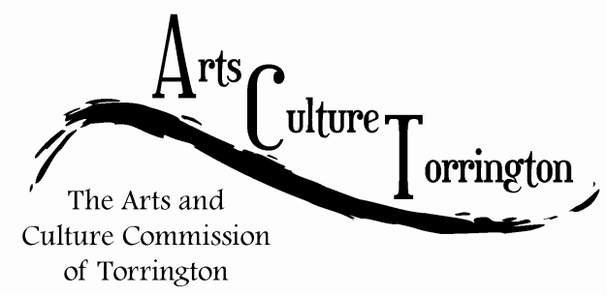

MINUTES

July 27th, 2016**|** 8:00am **|** City Hall Auditorium

Attendance: Ed Cannata, Jacque Williams, Kim McAllister, Marie Soliani, Janet Iffland, Rachel Kelly, Tim Waldron, Bill Haygood, Alexia Fox

The meeting was called to order by Chairman Ed Cannata at 8:10am

Tim Waldron introduced the Mayor’s summer intern, Alexia Fox, to the commission.

The minutes of the previous meeting were approved on a motion made by Marie Soliani, seconded by Bill Haygood

Marketplace update: Ed Cannata reported that this week’s theme is “Christmas in July” ACT will have a booth selling Christmas ornaments. Ed ordered additional Christmas Village ornaments to be sold. The commission discussed increasing the price from $12 to $15.00; a motion to raise the price was made by Marie Soliani, seconded by Rachel Kelly

Community Assessment update: Ed Cannata reported that he is getting a workbook to assist in creating a survey to gather information. The commission discussed ways to gather contact information for the purpose of getting survey respondents. A proposal for questions, prepared by Jacque Williams and Rachel Kelly was officially submitted into the minutes. A motion to accept page one of the proposal was made by Kim McAllister, seconded by Jacque Williams. A motion to table page 2 was made by Kim McAllister, seconded by Rachel Kelly. The commission discussed what questions would be asked of individuals at the Main Street Marketplace. The survey would be available at the ACT table.

New Business: Ed Cannata suggested compiling a list of all former ACT commissioners to be placed on the website to acknowledge their service, Tim Waldron would work with the City Clerk to compile this information.

Jacque Williams suggested that ACT work on getting photos of arts & culture related events for the facebook page and website. Commission members agreed that they could take pictures and upload them on their own, or send them to page administrators to do so.

CAFTA is holding a Rio block party on August 5th to celebrate the summer Olympics. Rachel Kelly reached out to explore ways ACT and CAFTA can collaborate

Artist Relocation Project – Jacque and Rachel are making plans to meet with City Planner Marty Connor and would coordinate having him attend the next meeting. Bill is meeting with Ed Jaffe to discuss updates and next steps

Jacque Williams made a suggestion of meeting twice a month. It was discussed that it may not be necessary to formally schedule twice monthly meetings, but that special meetings could be called when it was deemed necessary to convene the entire commission.

Ed Cannata suggested that ACT help coordinate banners on downtown poles. Tim would speak to the Mayor regarding the suggestion.

The next meeting will be held on Monday, August 8th, 2016 at a new time of 10:00AM

The meeting was adjourned on a motion made by Rachel Kelly, seconded by Kim McAllister at 9:15am

Respectfully submitted,

Tim Waldron