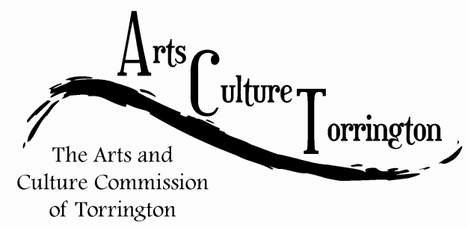

MINUTES

July 6th, 2016 (Adjourned from June 29, 2016)**|** 8:00am **|** City Hall Auditorium

Attendance: Ed Cannata, Jacque Williams, Kim McAllister, Mike McAllister, Marie Soliani, Janet Iffland, Rachel Kelly, Tim Waldron

The meeting was called to order by Chairman Ed Cannata at 8:07am

Motion to amend the minutes of the May 25th meeting made by Jacque Williams, second by Rachel Kelly, the minutes were amended to reflect that no survey was currently on Facebook. Minutes were approved as amended.

The commission formally welcomed Janet Iffland as the newest member.

Public Comment: Teresa and John Sullivan of the Connecticut Association For The Arts (CAFTA) and several members of their organization addressed the commission to speak of the various programs, projects and goals – classes, Friday night movies, fundraisers, student programs, Olympics block party.

Ideas & Initiatives: Marie Soliani suggested that ACT work with CAFTA to promote a Friday night movie devoted to Arts and Culture. Motion was made by Marie, seconded by Mike to have Chairman Ed Cannata reach out to CAFTA regarding the proposal.

Funding suggestions: Christmas ornaments to be sold at Main Street Market Place, committee members to help Janet Iffland sell on Thursday evenings. For the upcoming Christmas season, Ed will reach out to Lynn Gelormino to discuss having the Warner as the ornament, in addition to Christmas Village.

The commission felt that $500-$1000 in the ACT account would be a good goal. Another funding suggestion, made by Kim McAllister was a Beer & Wine tasting at Backstage or another venue, or possibly partnering with CAFTA.

Survey update: Jacque suggested that the ACT website be expanded. Ed touched upon investigating a regional arts collaboration. The commission discussed at length the merits of a survey vs a needs assessment. Kim McAllister made a motion to table the discussion, seconded by Marie Soliani. Jacque Williams voted in opposition to tabling the motion.

New Business: Kim McAllister suggested having a page in the Main Street Marketplace guide book.

Rachel Kelly is going to reach out to CAFTA to discuss partnerships and report back to the commission.

Jacque Williams is going to report on opportunities for social media

Ed will report the commission on his conversation with the Warner regarding a Christmas ornament.

The meeting was adjourned on a motion made by Marie Soliani, seconded by Kim McAllister at 9:20am.

Respectfully submitted,

Tim Waldron