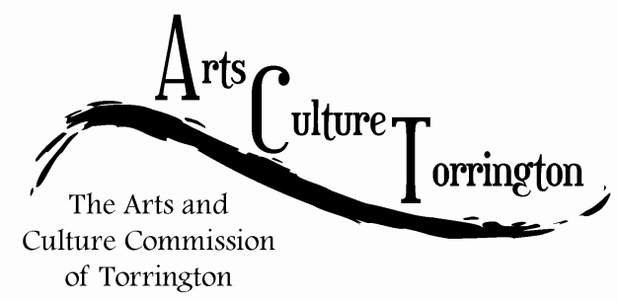

SPECIAL MEETING MINUTES

May 11, 2015**|** 3:00am **|** City Hall Auditorium

Attendance: Bill Haygood, Ed Cannata, Jacque Williams, Marie Soliani, Rachel Kelly, Tim Waldron, Erin Wilson, Mayor Elinor Carbone, John Cusano (DECD)

The meeting was called to order at 3:10pm

The commission was joined by John Cusano of the Connecticut Department of Economic & Community Development.

John discussed with the commission how the state is represented by various arts councils around the state.

The commission discussed various projects that ACT has started (marketplace, 5 points gallery) that have proven successful and have spun off to their own independent events.

John suggested that connecting with stakeholders in the community is an important step. This refers to both residents, and the arts and culture community. John was pleased to hear that ACT is already in the midst of a survey being distributed online.

John discussed with the commission the various resources that are available to ACT, such as the Americans for the Arts organization, and the Northwest CT Arts Council.

The commission brought up the fact that the City, Warner Theatre and UConn collaborated on a study regarding arts as an economic driver. John was pleased to hear that this was completed and encouraged ACT to continue with projects that show the value that arts and culture bring to a town.

John gave examples of communities such as Coventry who have made many strides in promoting their arts and culture offerings.

The meeting was adjourned at 4:30pm on a motion made by Jacque Williams, seconded by Bill Haygood.

Respectfully submitted,

Tim Waldron