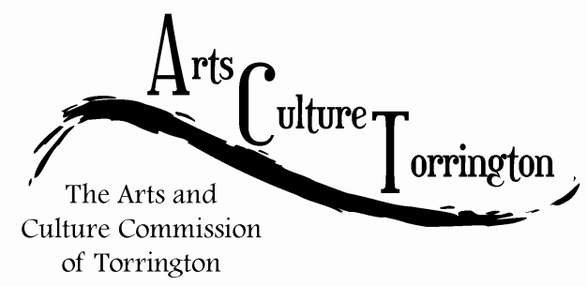

ACT SPECIAL MEETING MINUTES

March 30th, 2016**|** 8:00am **|** City Hall Auditorium

Attendance: Ed Cannata, Jacque Williams, Bill Haygood, Marie Soliani, Rachel Kelly, Kim McAllister, Tim Waldron. Guest- Janet Iffland

The meeting was called to order by Chairman Ed Cannata at 8:10am

Minutes of the previous meeting were approved on a motion made by Kim McAllister, seconded by Bill Haygood

The committee welcomed newly appointed Commissioner, Rachel Kelly.

Public Comment – None

Ideas & Initiatives:

The committee discussed sending a card to Fiona de Merell on the passing of her fiancé. Marie Soliani would hold the card at Hatfields and members can sign it before it is sent.

Tim Waldron reported that the Mayor had received a resignation from Fiona de Merell due to a change in work and residency. A motion was made by Marie Soliani to accept the resignation, seconded by Jacque.

Ed Cannata reported that he is in the process of finalizing details for a movie screening to be held at the movie theatre. The screening could be used as a fundraiser to help kick off the historic photo project in City Hall.

Bill Haygood is in the process of getting a copy of the photo that is proposed to be displayed in City Hall. Tim Waldron asked if a schematic drawing of the frame could be provided to show to the Public Works Director before the project is finalized.

Yarn Bombing update:

Bill Haygood reported that the organizers are in need of assistance on the day of the installation. The committee voiced their willingness to participate and volunteer on June 11th.

Survey Update:

Jacque reported that the first question is completed. “Where do you get your information from” the committee discussed the value of having questions available all at once, or on a weekly basis. Ed will be working with Jacque and Rachel to complete the remaining questions. The survey will be sent to the committee prior to the April meeting and will be voted on at that time. The committee discussed the ability to email survey respondents the results of the survey, as well as more information about ACT events and initiatives down the road.

DECD visit:

Tim Waldron briefed the committee on the purpose behind the visit by the Department of Economic & Community Development. He sent 3 dates to John Cusano and was waiting to hear back. The dates are: 4/7 4/19 and 4/13 all at 8:00am. Rachel Kelly said that she will be working on a project studying communities that are similar in size to Torrington as part of her senior project. The committee was interested in this and discussed it further.

The meeting was adjourned on a motion made by Bill Haygood, seconded by Kim McAllister. The meeting ended at 8:51am.

Respectfully submitted,

Tim Waldron