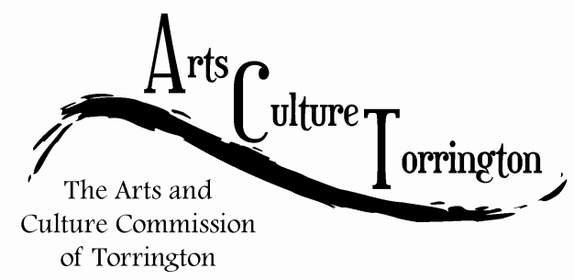

MINUTES

January 27th, 2016**|** 8:00am **|** City Hall Auditorium

Attendance: Ed Cannata, Jacque Williams, Bill Haygood, Kim McAllister, Mike McAllister, Tim Waldron

The meeting was called to order by Chairman Ed Cannata at 8:08am

Minutes of the December 30th ACT meeting were approved on a motion made by Bill Haygood, seconded by Mike McAllister

Public Comment: There were no members of the public in attendance

Ideas & Initiatives:

* Tim Waldron reported that he had found files from the Mayor’s Office and Parks & Recreation office relating to FirstNight. The event was put on by a separate committee and not organized by the City so there was not a ton of information available. The committee discussed the idea of reviving the event and decided that more due diligence was needed first. Various commissioners offered to call individuals who were involved in the event to gain feedback.
* Mike McAllister reported on Main Street Torrington taking over Marketplace. The committee discussed possibly having a booth to showcase the committee, ornaments, etc.

CT Culture & Tourism:

* Tim Waldron reported that he heard back from John Cusano at the State DECD regarding visiting an ACT meeting. Tim is calling him to arrange a date/time

Survey:

* Motion to table discussion made by Ed Cannata, seconded by Jacque Williams

Motion to adjourn made by Jacque Williams, seconded by Mike McAllister, the meeting was adjourned at 8:55

Respectfully submitted,

Tim Waldron