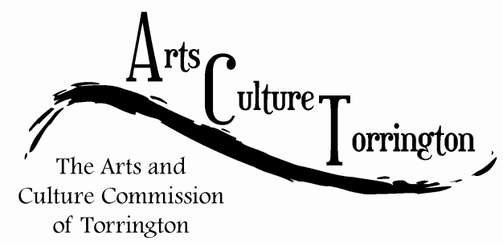

MINUTES

July 20, 2015│9:00am│UConn Torrington

Attendance: Ed Cannata, Fiona DeMerell, Marie Soliani, Bill Haygood, Jacque Williams, Tim Waldron

The meeting was called to order by Chairman Ed Cannata at 9:06am.

City Ordinance:

Discussed the responsibilities of the Arts Blanket covered in 35C

Fiona DeMerell commented on possibly getting money for projects through city budget

Discussion regarding the wide scope of A & C Commission ended with the committee agreeing that the ordinance did not need to be updated.

Questions were asked about how the commission will obtain grants and if the city is willing to fund them by Ed Cannata and Fiona DeMerell. Jacque Williams inquired if funding was available for specific projects. Tim Waldron has agreed to look into this.

Ed suggests inviting John Cusano to speak with the Commission. Bill Haygood suggests networking with other towns and fact checking, research should be brought to the next full meeting.

Vacancies:

Tim will check on the procedure for presenting nominees and how to get resumes to the Mayor and Commissioners.

Characteristics preferred:

* 1. Connected to the people of Torrington
  2. Someone with ideas and abilities
  3. Connected to local businesses

Commissioners were encouraged to suggest names of people who would fit the job.

John Brown Monument:

All agree this is a great idea due to the larger scope of what he represents in history, culture, etc. Visiting the John Brown Museum was suggested. A lengthy conversation permitting to how the project would fit into the culture aspect of the committee was discussed.

The meeting was adjourned at 10:30am on a motion made by Jacque Williams, seconded by Fiona DeMerell. The next meeting will take place at City Hall on July 29th at 8:00am.

Respectfully submitted,

Tim Waldron