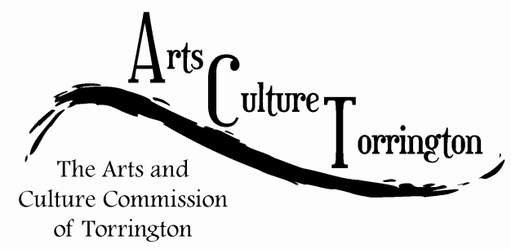

MEETING AGENDA

March 29, 2017 **|** 8:00am **|** City Hall **Room 215**

1. Call To Order
2. Public Comment
3. Approve minutes from special meeting 02/22/2017
4. Budget Review
5. **Event Update:** “Saturday in the Park”
6. **Committee Update:**

* Community Engagement
* City Space (historic photo project) (hanging system for auditorium)

1. New Business
2. Adjournment