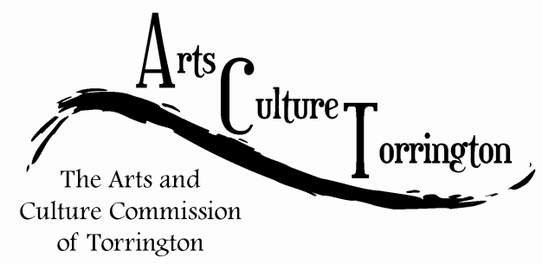

SPECIAL MEETING AGENDA

January 18th, 2017**|** 8:00am **|** City Hall Auditorium

1. Call To Order
2. City Space – City Hall photo project discussion
3. Saturday in the Park – planning
4. Adjourn