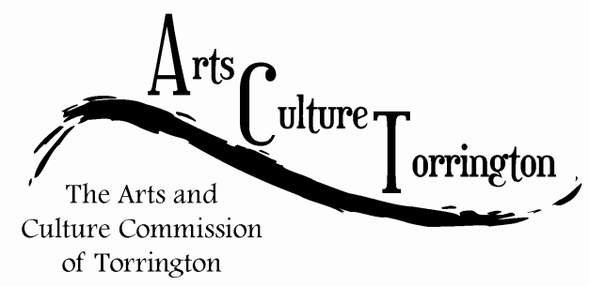

MEETING AGENDA
October 26th, 2016 | 8:00am | City Hall, Room 224

- Call To Order
- Public Comment
- Approve minutes of September 28th 2016 meeting
- Artist relocation program update
- Survey/ornament update
- Art Festival update
- Social Media update
- Discussion: City Hall photo project
- New business
- Adjournment

