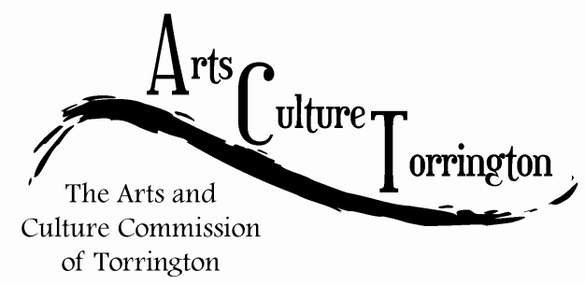

MEETING AGENDA
August 31st, 2016 | 8:00am | City Hall, Room 224

- Call To Order
- Public Comment
- Approve minutes of July 27th 2016 meeting
- Approve minutes of August 8th 2016 special meeting
- Artist relocation program update
- Survey/ornament update
- Discussion: Art Festival
- Discussion: City Hall photo project
- New business
- Adjournment

