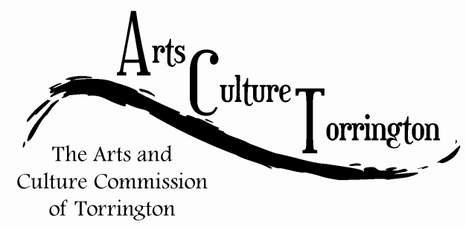

AGENDA
June 25, 2014| 10:00am – 11am | City Hall Auditorium

- Call To Order
- Open Public Meeting
- Acceptance of previous Meeting Minutes
- Main Street Marketplace Update
  - Vendors
  - Entertainment
  - Sponsorship
  - Promotions
  - Volunteers
  - Theme Weeks
- Fall Music Festival in Participation with Park and Rec. (Jacque)
- Vacant commission position: A wish list of traits and qualities for future commissioners
- Adjournment

