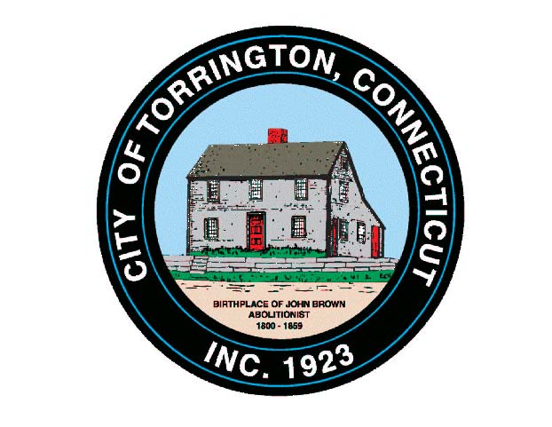 |  | CITY OF TORRINGTON -- MEETING SCHEDULE  October 2016
Monday, Oct. 3 | Ordinance Committee |  | 6:00 p.m., City Hall Room 215
Monday, Oct. 3 | Small Cities Committee |  | 6:15 p.m., City Hall Room 224
Monday, Oct. 3 | City Council & WPC Authority |  | 6:30 p.m., City Hall Auditorium
Tuesday, Oct. 4 | Session to Complete Preliminary List |  | 9:00 a.m. – 4:00 p.m., Registrar of Voters’ Office
Tuesday, Oct. 4 | LEPC/EOC |  | 10:00 a.m., 111 Water Street
Tuesday, Oct. 4 | Economic Development Commission |  | 5:00 p.m., City Hall Auditorium
Tuesday, Oct. 4 | Torr. Trails Network |  | 6:00 p.m., City Hall Room 215
Wednesday, Oct. 5 | Tentative: Vehicle Replacement Advisory Comm. |  | 8:30 a.m., Mayor’s Office
Wednesday, Oct. 5 | Parks & Recreation Commission |  | 5:00 p.m., Armory
Wednesday, Oct. 5 | Brd. of Education Policy Committee |  | 6:00 p.m., 355 Migeon Ave.
Wednesday, Oct. 5 | Brd. of Public Safety |  | 6:30 p.m., City Hall Auditorium
Wednesday, Oct. 5 | Brd. of Education Sch. Improvmt. Comm. |  | 7:00 p.m., 355 Migeon Ave.
Thursday, Oct. 6
Friday, Oct. 7

Monday, Oct. 10 | Columbus Day – City Hall Closed
Tuesday, Oct. 11 | Western Region Water Utility Coord. | 10:00 a.m., Brookfield Town Hall
Tuesday, Oct. 11 | Torr. Trails Network | 6:00 p.m., City Hall Room 215
Wednesday, Oct. 12 | Torrington Housing Authority | 12:00 Noon, Community Rm., Michael Koury Terr.
Wednesday, Oct. 12 | Brd. of Education Personnel Committee | 6:00 p.m., 355 Migeon Ave.
Wednesday, Oct. 12 | Brd. of Education Budget Committee | 6:30 p.m., 355 Migeon Ave.
Wednesday, Oct. 12 | Planning & Zoning Commission | 7:00 p.m., City Hall Auditorium
Thursday, Oct. 13 | Parking Ticket Appeals | 9:30 a.m., City Hall Room 224
Thursday, Oct. 13 | NHCOG | 10:00 a.m., 42 North St., Goshen
Thursday, Oct. 13 | Conservation Commission | 6:30 p.m., City Hall Room 324
Friday, Oct. 14

Monday, Oct. 17 | TECC Education Workgroup | 12:00 Noon, 355 Migeon Ave.
Monday, Oct. 17 | Services for the Elderly | 1:00 p.m., Senior Center
Monday, Oct. 17 | Tentative: Public Hearing – Volunteer FF | 6:30 p.m., City Hall Auditorium*
Monday, Oct. 17 | City Council & WPC Authority | *Immediately Following, City Hall Auditorium
Tuesday, Oct. 18 | Board of Finance | 5:00 p.m., City Hall Auditorium
Tuesday, Oct. 18 | Torr. Trails Network | 6:00 p.m., City Hall Room 215
Tuesday, Oct. 18 | Inland Wetlands Commission | 7:00 p.m., City Hall Auditorium
Wednesday, Oct. 19 | Western CT Tourism Executive Board | 10:00 a.m, Conference Call
Wednesday, Oct. 19 | NW CT Transit District | 10:00 a.m., 957 E. Main St.
Wednesday, Oct. 19 | Coe Memorial Park Committee | 5:00 p.m., Coe Park Civic Center
Wednesday, Oct. 19 | Board of Education | 6:00 p.m., T H S
Thursday, Oct. 20 | TECC – LICC | 9:00 a.m. – 11:00 a.m., 157 Litchfield Street
Thursday, Oct. 20 | Mayor’s Committee on Youth | 6:00 p.m., City Hall Auditorium
Friday, Oct. 21

Monday, Oct. 24
Tuesday, Oct. 25 | Torr. Trails Network | 6:00 p.m., City Hall Room 215
Wednesday, Oct. 26 | Arts & Culture Commission | 8:00 a.m., City Hall Auditorium
Wednesday, Oct. 26 | Torrington Housing Authority | 12:00 Noon, Community Rm., Michael Koury Terr.
Wednesday, Oct. 26 | Board of Ethics | 6:00 p.m., City Hall Room 311
Wednesday, Oct. 26 | Planning & Zoning Commission | 7:00 p.m., City Hall Auditorium
Thursday, Oct. 27 | Torrington Veterans’ Support Committee | 6:30 p.m., City Hall Room 224
Thursday, Oct. 27 | Litchfield County Dispatch, Brd. of Directors | 7:00 p.m., 111 Water Street
Friday, Oct. 28

