 | 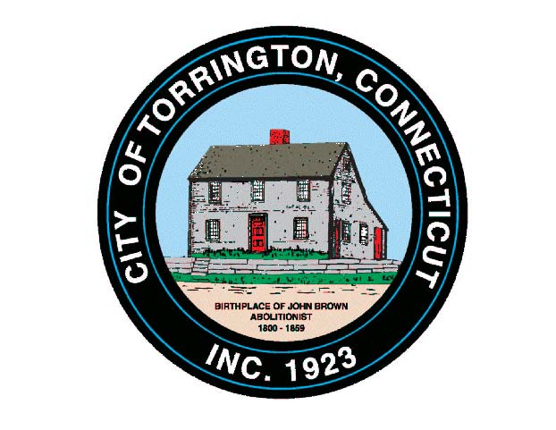 |  | CITY OF TORRINGTON  MEETING SCHEDULE  2016
Sunday
September 25
Monday
September 26
Tuesday  September 27 |  | Torrington Trails Network |  | 6:00 p.m., City Hall Room 215
Wednesday  September 28 |  | Arts & Culture Commission |  | 8:00 a.m., City Hall Auditorium
 |  | Torrington Housing Authority |  | 12:00 Noon, Community Room, Michael Koury Terrace
 |  | Board of Ethics |  | 6:00 p.m., City Hall Room 311
Thursday  September 29 |  | Litchfield County Dispatch  Board of Directors |  | 7:00 p.m., 111 Water Street
Friday
September 30
Saturday
September 31

