 | 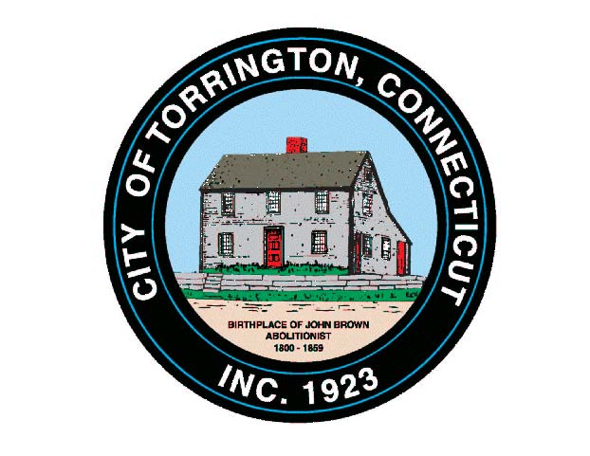 |  | CITY OF TORRINGTON  MEETING SCHEDULE  2016
Sunday
September 18
Monday  September 19 |  | Services for the Elderly Commission |  |  | 1:00 p.m., Senior Center
 |  | Board of Assessment Appeals |  |  | 2:00 p.m. – 6:30 p.m., City Hall Room 311
 |  | City Council & WPC Authority |  |  | 6:30 p.m., City Hall Auditorium
Tuesday  September 20 |  | Board of Finance |  |  | 5:00 p.m., City Hall Auditorium
 |  | Inland Wetlands Commission |  |  | 7:00 p.m., City Hall Auditorium
Wednesday  September 21 |  | Western CT Tourism District, Full Board |  |  | 10:00 a.m., 144 W. Main, Waterbury
 |  | NWCT Transit District |  |  | 1:00 p.m., 957 E. Main St.
 |  | Coe Memorial Park Special Projects Committee |  |  | 4:30 p.m., Coe Memorial Park Civic Center
 |  | Coe Memorial Park Committee |  |  | 5:00 p.m., Coe Memorial Park Civic Center
 |  | Board of Education |  |  | 6:00 p.m., 355 Migeon Ave.
Thursday  September 22 |  | Torrington Veterans Support Committee |  |  | 6:30 p.m., City Hall Room 224
Friday
September 23
Saturday
September 24

