 | 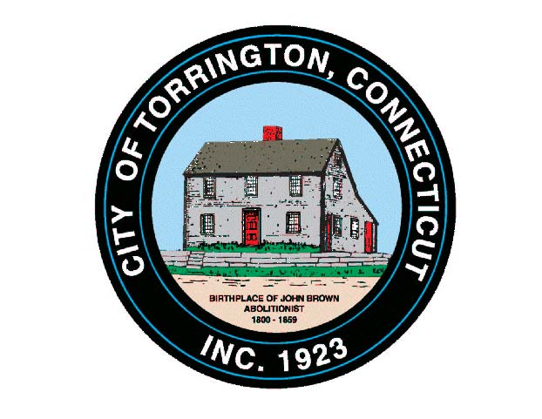 |  | CITY OF TORRINGTON  MEETING SCHEDULE  2016
Sunday
September 11
Monday  September 12 |  | TECC Educ. Workgroup |  |  | 12:00 Noon – 2:00 p.m., 355 Migeon Ave.
 |  | Zoning Board of Appeals |  |  | 7:00 p.m., City Hall Auditorium
Tuesday  September 13 |  | Torrington Development Corp. |  |  | 8:00 a.m., City Hall Auditorium
 |  | Torrington Trails Network |  |  | 6:00 p.m., City Hall Room 215
Wednesday  September 14 |  | Torrington Housing Authority |  |  | 12:00 Noon – Community Rm., M. Koury Terrace
 |  | Board of Education Personnel Committee |  |  | 6:00 p.m., 355 Migeon Ave.
 |  | Board of Education Budget Committee |  |  | 6:30 p.m., 355 Migeon Ave.
 |  | Planning & Zoning Commission |  |  | 7:00 p.m., City Hall Auditorium
 |  | Fire Service Coordination Committee |  |  | 7:00 p.m., Torrington EOC, 111 Water Street
Thursday  September 15 |  | TECC – LICC |  |  | 9:00 a.m. – 11:00 a.m., 157 Litchfield St.
 |  | Mayor’s Committee on Youth |  |  | 6:00 p.m., City Hall Auditorium
 |  | Torrington Area Health District |  |  | 7:00 p.m., 350 Main Street
Friday
September 16
Saturday
September 17

