 | 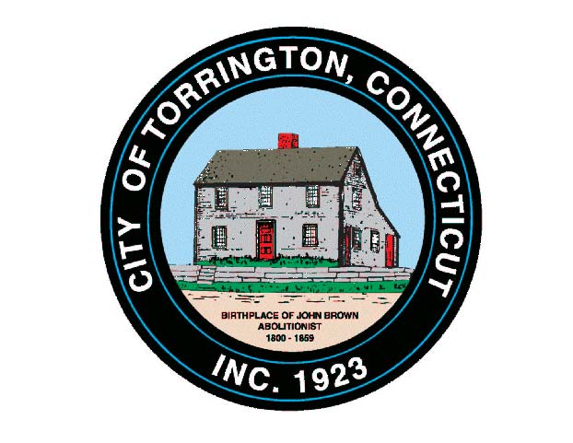 |  | CITY OF TORRINGTON  MEETING SCHEDULE  2016
Sunday
September 4
Monday  September 5 |  | Labor Day – City Hall Closed
Tuesday  September 6 |  | Economic Development Commission |  |  | 5:00 p.m., City Hall Auditorium
 |  | SPEC. Brd. of Educ. Exec. Comm. |  |  | 5:30 p.m., 355 Migeon Ave.
 |  | Small Cities Committee |  |  | 6:15 p.m., City Hall Room 215
 |  | PUBLIC HEARING: Veterans’ Tax Exemptions |  |  | 6:30 p.m. City Hall Auditorium
 |  | City Council & WPC Authority |  |  | 6:30 p.m., City Hall Auditorium*
 |  | Brd. of Trustees City Employees Retirement Fund |  |  | *Immediately Following
Wednesday  September 7 |  | Parks & Recreation Commission |  |  | 5:00 p.m., Coe Park Civic Center
 |  | Board of Educ. School Improvement Comm. |  |  | 6:00 p.m., 355 Migeon Ave.
 |  | Board Trustees Police Firemen Pension Fund |  |  | 6:30 p.m., City Hall Auditorium*
 |  | Board of Public Safety |  |  | *Immediately Following
 |  | Board of Education Policy Committee |  |  | 7:00 p.m., 355 Migeon Ave.
Thursday  September 8 |  | Parking Ticket Appeals |  |  | 9:30 a.m., City Hall Room 224
 |  | NHCOG |  |  | 10:00 a.m., 59 Torrington Rd. A-1, Goshen
 |  | Conservation Commission |  |  | 6:30 p.m., City Hall Room 324
 |  | Cable TV Advisory Council |  |  | 6:30 p.m. Oliver Wolcott Library, Litchfield
Friday
September 9
Saturday
September 10

