 | 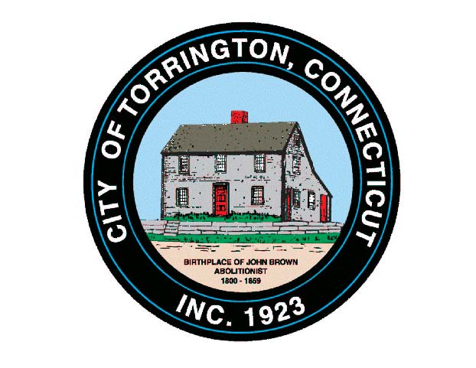 |  | CITY OF TORRINGTON  MEETING SCHEDULE  2016
Sunday
August 28
Monday
August 29
Tuesday
August 30
Wednesday August 31 |  | Arts & Culture Commission |  |  | 8:00 a.m., City Hall Auditorium
Thursday
September 1
Friday
September 2
Saturday
September 3

