 | 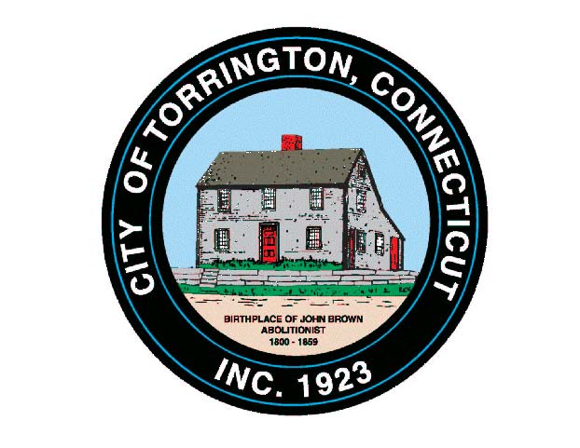 |  | CITY OF TORRINGTON  MEETING SCHEDULE  2016
Sunday
August 21
Monday
August 22
Tuesday
August 23
Wednesday August 24 |  | Torrington Housing Authority |  |  | 12:00 Noon, M. Koury Terr. Community Rm.
Thursday  August 25 |  | Litchfield County Dispatch Board of Directors |  |  | 7:00 p.m., 111 Water Street
Friday
August 26
Saturday
August 27

