 | 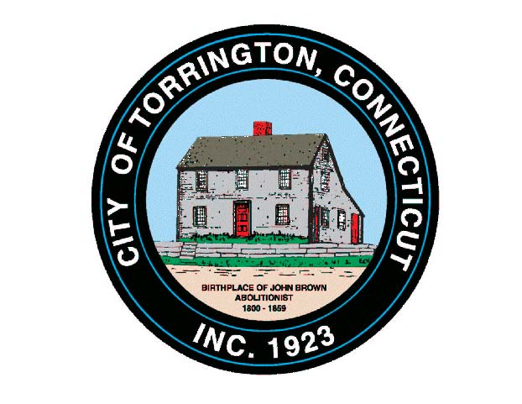 |  | CITY OF TORRINGTON  MEETING SCHEDULE  2016
Sunday
August 14
Monday  August 15 |  | Ordinance Committee |  |  | 6:00 p.m., City Hall Room 215
 |  | PUBLIC HEARING: Tax Refund Ordinance |  |  | 6:30 p.m., City Hall Auditorium*
 |  | City Council & WPC Authority |  |  | *Immediately Following
Tuesday  August 16 |  | Board of Finance |  |  | 5:00 p.m., City Hall Auditorium
 |  | Inland Wetlands Commission |  |  | 7:00 p.m., City Hall Auditorium
Wednesday August 17 |  | Western CT Tourism District, Exec. Board |  |  | 10:00 a.m., Conference Call
 |  | Coe Memorial Park Committee |  |  | 5:00 p.m., Coe Memorial Park Civic Center
 |  | Board of Education |  |  | 6:00 p.m., 355 Migeon Ave.
Thursday
August 18
Friday
August 19
Saturday
August 20

