 | 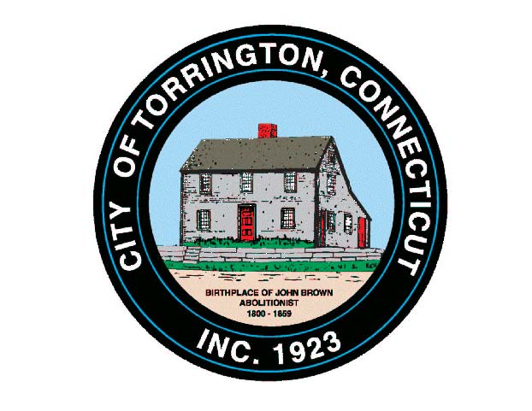 |  | CITY OF TORRINGTON  MEETING SCHEDULE  2016
Sunday
August 7
Monday  August 8 |  | Special Arts & Culture Commission |  |  | 10:00 a.m., City Hall Room 224
Tuesday  August 9 |  | Republican State Primary – 63rd District |  | Voting Districts 1 & 4 Open 6:00 a.m. to 8:00 p.m.
 |  | Torrington Devel. Corp. – Exec. Brd. |  | 8:00 a.m., Mayor’s Office
 |  | Torr. Trails Network |  | 6:00 p.m., City Hall Room 215
Wednesday August 10 |  | Torrington Housing Authority |  |  | 12:00 Noon, Commun. Rm., M.Koury Terrace
 |  | Parks & Recreation Commission  Adjourned from August 3, 2016 |  |  | 5:00 p.m., Armory
 |  | Board of Education Personnel Committee |  |  | 6:00 p.m., 355 Migeon Ave.
 |  | Board of Education Budget Committee |  |  | 6:30 p.m., 355 Migeon Ave.
 |  | Planning & Zoning Commission |  |  | 7:00 p.m., City Hall Auditorium
Thursday  August 11 |  | Parking Ticket Appeals |  | 9:30 a.m., City Hall Room 224
Friday
August 12
Saturday
August 13

