 | 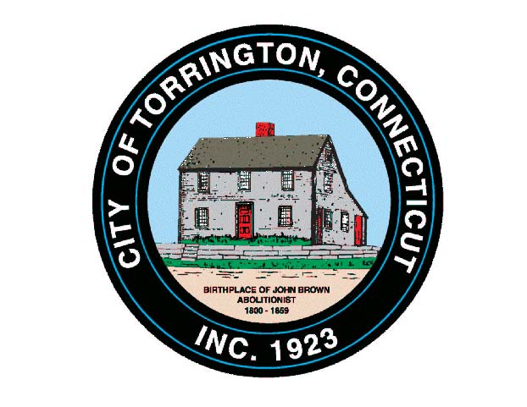 |  | CITY OF TORRINGTON  MEETING SCHEDULE  2016
Sunday
July 31
Monday  August 1 |  | Small Cities Committee |  |  | 6:15 p.m., City Hall Room 215
 |  | City Council & WPC Authority |  |  | 6:30 p.m., City Hall Auditorium*
Tuesday  August 2 |  | Economic Development Commission |  |  |  | 5:00 p.m., City Hall Auditorium
 |  | Conservation Commission |  |  |  | 6:30 p.m., City Hall Room 324
Wednesday  August 3 |  | Parks & Recreation Commission |  |  | 5:00 p.m., Armory
 |  | Board of Education Policy Committee |  |  | 6:00 p.m., 355 Migeon Ave.
 |  | Board of Educ. School Improvement Comm. |  |  | 7:00 p.m., 355 Migeon Ave.
 |  | Board of Public Safety |  |  | 6:30 p.m., City Hall Auditorium
Thursday
August 4
Friday
August 5
Saturday
August 6

