 | 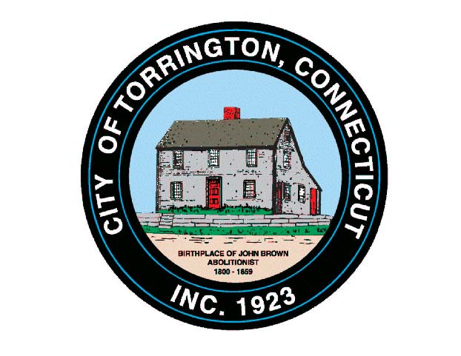 |  | CITY OF TORRINGTON  MEETING SCHEDULE  2016
Sunday
July 24
Monday
July 25
Tuesday  July 26 |  | Special Telephonic Board of Public Safety |  |  | 3:00 p.m. Mayor’s Office
 |  | Primary Enrollment Session |  |  | 5:00 p.m. – 7:00, Registrar of Voter’s Office
Wednesday July 27 |  | Arts & Culture Commission |  |  | 8:00 a.m., City Hall Auditorium
 |  | Torrington Housing Authority |  |  | 12:00 Noon, Comm. Room, M. Koury Terr.
Thursday  July 28 |  | Architectural Review Committee |  |  | 5:00 p.m., City Hall Room 324, Land Use
 |  | Torrington Veterans’ Support Committee |  |  | 6:30 p.m., City Hall Room 224
 |  | Litchfield County Dispatch, Board of Directors |  |  | 7:00 p.m., 111 Water Street
Friday
July 29
Saturday
July 30

