 | 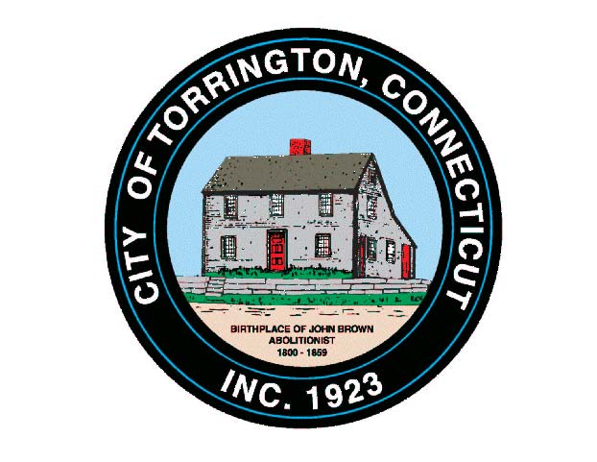 |  | CITY OF TORRINGTON  MEETING SCHEDULE  2015
Sunday
August 23
Monday
August 24
Tuesday  August 25 |  | Special Economic Development Commission |  |  | 5:00 p.m., City Hall Auditorium
Wednesday  August 26 |  | Arts & Culture Commission |  |  | 8:00 a.m., City Hall Auditorium
 |  | Torrington Housing Authority  Board of Public Safety, Police Personnel |  |  | 12:00 p.m., 110 Prospect St.  5:00 p.m., 576 Main St.
 |  | Board of Ethics |  |  | 6:00 p.m., City Hall Room 311
Thursday  August 27 |  | Litchfield County Dispatch Brd. of Directors |  |  | 7:00 p.m., 111 Water Street
Friday
August 28
Saturday
August 29

