 | 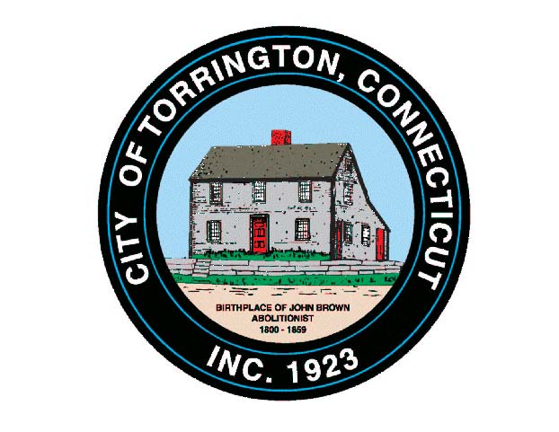 |  | CITY OF TORRINGTON  MEETING SCHEDULE  2015
Sunday
January 11
Monday  January 12 |  | TECC Steering Committee |  |  | 10:00 am, 355 Migeon Ave.
 |  | TECC Educ. Workgroup |  |  | 12:00 pm, 355 Migeon Ave.
 |  | Zoning Board of Appeals |  |  | 7:00 pm, City Hall Auditorium
Tuesday  January 13 |  | Torrington Development Corporation |  |  | 8:00 am, City Hall Auditorium
 |  | Economic Development Commission |  |  | 5:00 pm, City Hall Auditorium
Wednesday January 14 |  | Torrington Housing Authority |  |  | 12:00 pm, 110 Prospect St.
 |  | THS Athletic Fields Bldg. Comm. (Turf) |  |  | 6:00 pm, City Hall, Room 215
 |  | Board of Education Personnel Committee |  |  | 6:00 pm, 355 Migeon Ave.
 |  | Board of Education Budget Committee |  |  | 7:00 pm, 355 Migeon Ave.
 |  | Fire Service Coordination Committee |  |  | 7:00 pm, 111 Water St.
 |  | Special Flood & Erosion Control Board |  |  | 7:00 pm, City Hall Auditorium*
 |  | Planning & Zoning Commission |  |  | *Immed. Following, City Hall Auditorium
Thursday  January 15 |  | TECC LICC |  |  | 9:00 am, 32 City Hall Ave.
 |  | Mayor’s Committee on Youth |  |  | 6:00 pm, Mayor’s Office
 |  | Cable TV Advisory Committee |  |  | 6:30 pm, Oliver Wolcott Library, Litchfield
 |  | Torrington Area Health District |  |  | 7:00 pm, 350 Main St.
Friday
January 16
Saturday
January 17

