 | 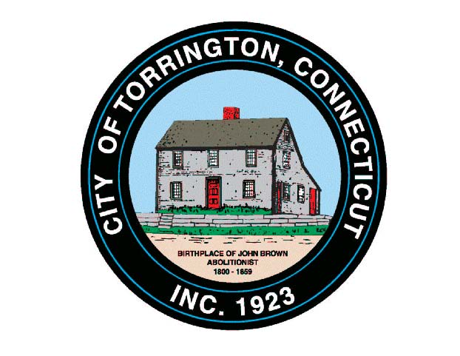 |  | 2013  CITY OF TORRINGTON  MEETING SCHEDULE
Monday  April 22 |  | TECC Sustainability Workgroup |  | 1:30 pm, 32 City Hall Ave.
Tuesday
April 23
Wednesday  April 24 |  | Arts & Culture Commission |  | 10:00 am, Auditorium
 |  | Torrington Housing Authority |  | 12:00 Noon, 110 Prospect St.
 |  | Board of Education |  | 7:00 pm, Torrington High School
 |  | CANCELLED: Planning & Zoning Commission |  | 7:00 pm, Auditorium
Thursday  April 25 |  | Architectural Review Committee  Torrington Veterans' Support Committee |  | 5:00 pm, Land Use Office  6:30 pm, Room 224
Friday  April 26 |  | TECC Steering Committee |  | 9:00 am, 355 Migeon Ave.
Saturday
April 27

Sunday
April 28

