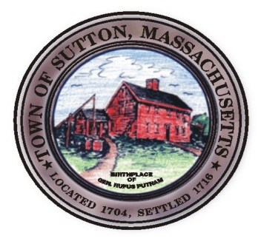

TOWN OF SUTTON ZONING BOARD OF APPEALS
4 UXBRIDGE ROAD · SUTTON, MA 01590 · (508) 865-8723 · FAX (508) 865-8721

ZONING BOARD OF APPEALS
MINUTES
November 6, 2014

Approved by:___________________
Date:_________________________

Zoning Board Members Present: Rick Deschenes, Chairman; Jeffrey Fenuccio, Clerk; Michael
McGovern; Rich Haskins; Brittanie Reinold;
Secretary: Lynn Dahlin

All others present:

7:30pm – Public Hearing Continued : Special Permit
140 Worc. Prov. Turnpike
Charles Hodgkins

R. Deschenes informed the Board that notification had been received by the applicant who had decided to move in another direction. R. Haskins motioned, J. Fenuccio seconded and the vote unanimous to grant a withdrawal without prejudice based on the October 31, 2014 correspondence received by the petitioner.

Board Business:

Review of Minutes:
J. Fenuccio motioned, R. Haskins seconded and the vote unanimous to approve the October 2, 2014 minutes as written.

7:32 – Meeting Adjourned

Respectfully submitted,

Lynn Dahlin
BOA Secretary

