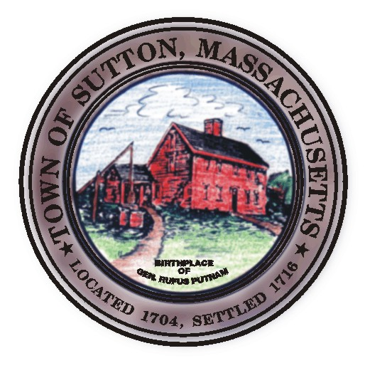

TOWN OF SUTTON ZONING BOARD OF APPEALS
4 UXBRIDGE ROAD · SUTTON, MA 01590 · (508) 865-8723 · FAX (508) 865-8721

Zoning Board of Appeals

January 8, 2009

Meeting Cancelled

