MEETING AGENDA To: Stratham 300TH Anniversary Committee
DATE: Monday, July 21, 2014, 6:30PM at the Stratham Municipal Center

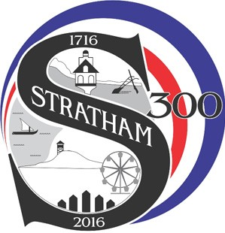Committee Members:

□ | Susan Canada, Secretary |  |  | □ | Pat Sapienza
□ | Lizabeth Chisholm | □ | Cathy Kenny, Treasurer | □ | Flossie Wiggin
□ | John Dold, Chair | □ | Joyce Rowe | □ | Peter Wiggin
□ | Jeff Gallagher |  | Carol Hazekamp
Also Present:

1. Call to Order

