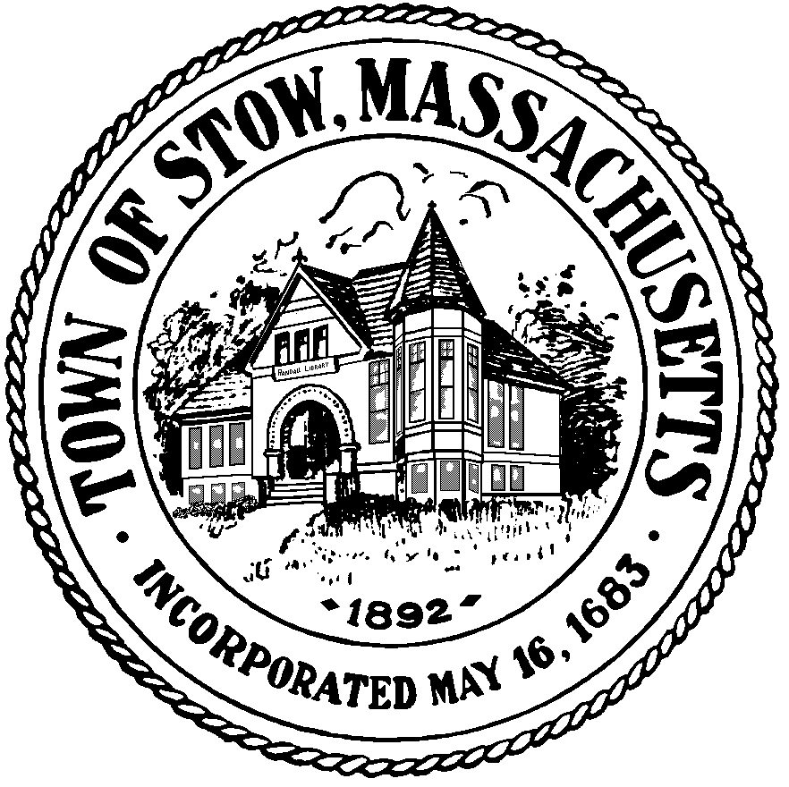

Town of Stow

PLANNING BOARD

**380 Great Road**

**Stow, Massachusetts 01775-1122**

**(978) 897-5098**

**FAX (978) 897-2321**

September 11, 2013

LEGAL NOTICE OF PUBLIC HEARING

Notice is hereby given that the Stow Planning Board will hold a public hearing on October 8, 2013 at 7:30 PM in the Stow Town Building, 380 Great Road, Stow, Massachusetts to discuss proposed amendments to the Stow Zoning Bylaw by:

Adding a new Section 10 to adopt a temporary moratorium on the use of land and or structures for Medical Marijuana Treatment Centers through November 30, 2014;

Amending the 8.9.4 (Inclusion of Affordable Housing), making non-substantive changes to the numbering of the bylaw references and replacing the word “may” with the word “shall” to clarify the intent in determining the number of required affordable dwelling units.

The proposed text may be viewed at the Office of the Planning Board or Office of the Town Clerk during normal business hours.

Lori Clark

Chairman