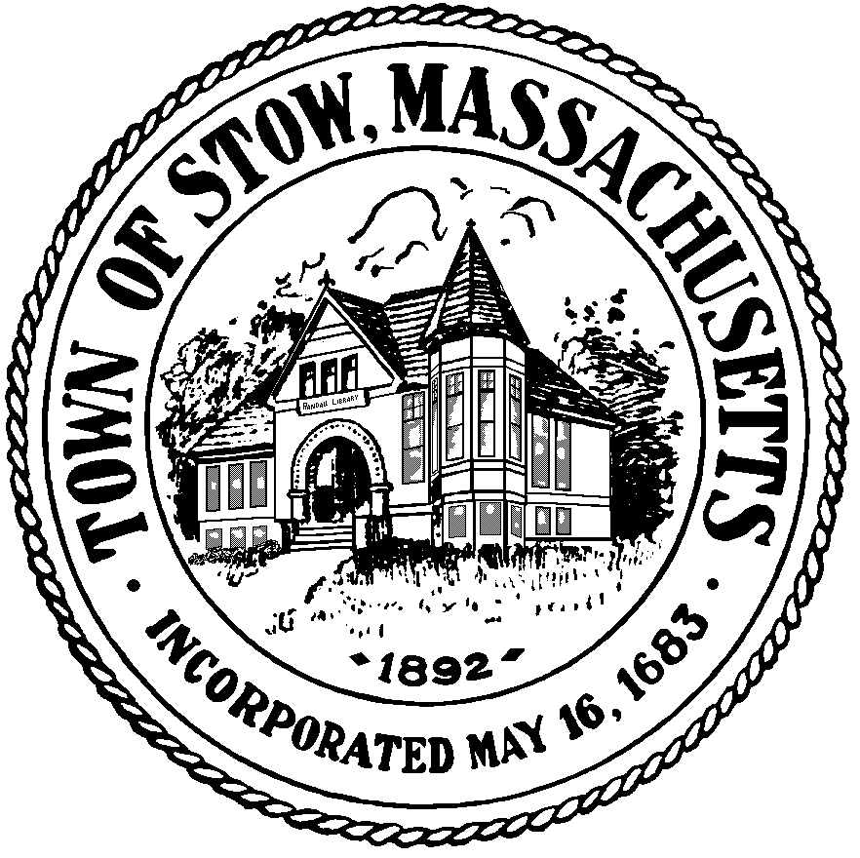

Town of Stow
Finance Committee

Town Building - 380 Great Road
Stow, Massachusetts 01775-2127
(978) 897-4514 x 1
FAX (978) 897-4534

Approved
Minutes
December 13, 2016

Members Present:
Peter McManus, Chair (PM)
Werner Fritz (WF)
Paul McLaughlin PL)
Julianne North (JN)

Others Present:
Kathleen Farrell, Administrative Assistant
Atli Thorarensen, Finance Committee Associate (AT)
Arthur Jurczyk, Finance Committee Associate (AJ)
Brooke Clenchy, Superintendent Nashoba RSD (BC)
Mark Jones, Member Nashoba Regional School Committee (MJ)

Call to Order: 7:30pm

Committee welcomed Arthur Jurczyk as an Associate Committee Member appointed by the Town Moderator

Reserve Fund Transfer Requests none

Review of Minutes
(WF) moved to approve minutes of November 22, 2016 (JN) second, unanimous support
Liaison Reports
8:00pm Brooke Clenchy, Superintendent of the Nashoba Regional School District came to the meeting to introduce herself and answer any questions
Contracts are up this year and 80% of the budget is staffing
(AT) Asked about increasing costs like health insurance and Special Education
(BC) The Special Education population continues to grow
8:15pm Mark Jones came to talk to the committee about the timing of the School District Budget planning
He shared with the committee FY 17 Revenues by Source, Line Item Control Accounts, budget drivers and enrollment projections

Next Meeting 1/10/17 at 7:00pm
9:30pm Meeting adjourned

