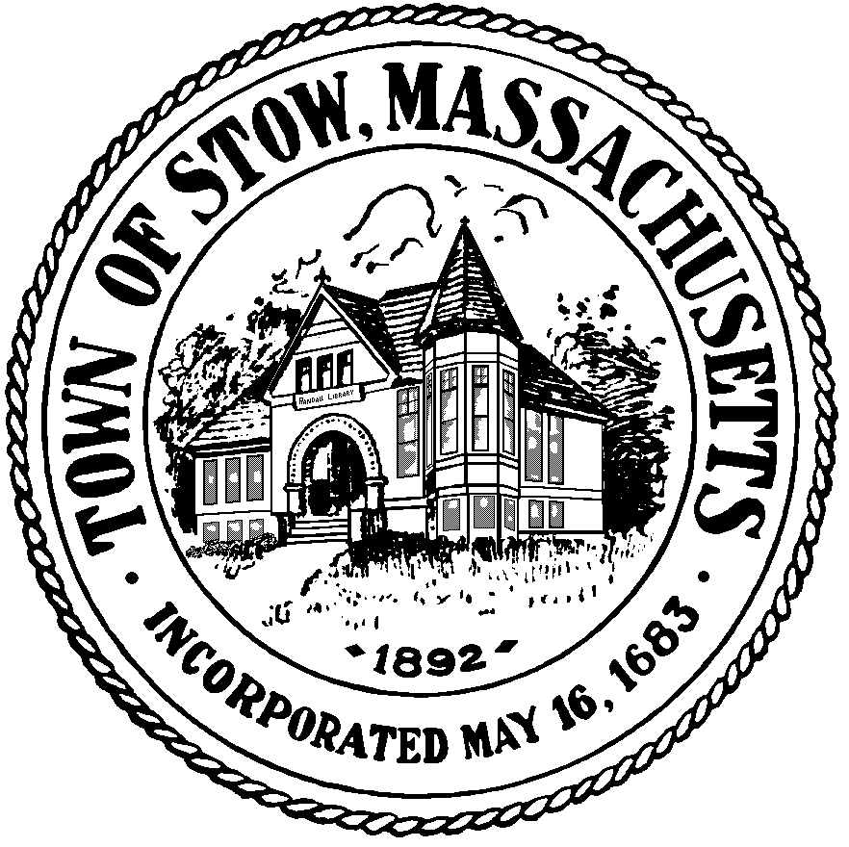

### Town of Stow

**Finance Committee**

**Town Building - 380 Great Road**

**Stow, Massachusetts 01775-2127**

**(978) 897-4514 x 1**

**FAX (978) 897-4534**

**Approved**

Minutes

October 25, 2016

Members Present:

Peter McManus, Chair (PM)

Richard Eckel (RE)

Werner Fritz (WF)

Paul McLaughlin (PL)

Julianne North (JN)

Others Present:

Kathleen Farrell, Administrative Assistant

David Walrath, Town Moderator (DW) (7:30pm-8:30pm)

Linda Hathaway, Town Clerk (LH) (8:00-8:20pm)

Atli Thorenson (AT)

Arthur Jurczyk (AJ)

**Call to Order**: 7:30pm

The Finance Committee welcomed Atli Thorarensen as Associate member

General discussion of membership

**Reserve Fund Transfer Requests -** none

(PM) Explained in general terms the need for Reserve Fund Transfers

**Review Minutes**

7:40pm PM moved to accept the minutes of October 11, 2016 as amended, RE second. Unanimous support

**Liaison Reports**

(PL) General discussion of CPC meeting including planning/funding of proposed Plantation project

(AT) Was there an upgrade in design?

(PL) Request was for engineering to avoid pollution – questions surrounding whether it was a legitimate use of CPC funds

General discussion of library renovation planned for winter 2018

8:00pm (LH) General update on early voting and readiness of Town for election

**Other Business**

General discussion about liaison appointments, will discuss at next meeting

8:44pm (RE) moved to appoint Atli Thorarensen as voting member of the Community Preservation Committee, upon being sworn in by the Town Clerk as Associate member of the Finance Committee. (JN) second, unanimous support

**Next Meeting** 11/22/16 at 7:30pm

9:03pm (WF) moved to adjourn, (PM) second, unanimous support

8:42pm Meeting adjourned