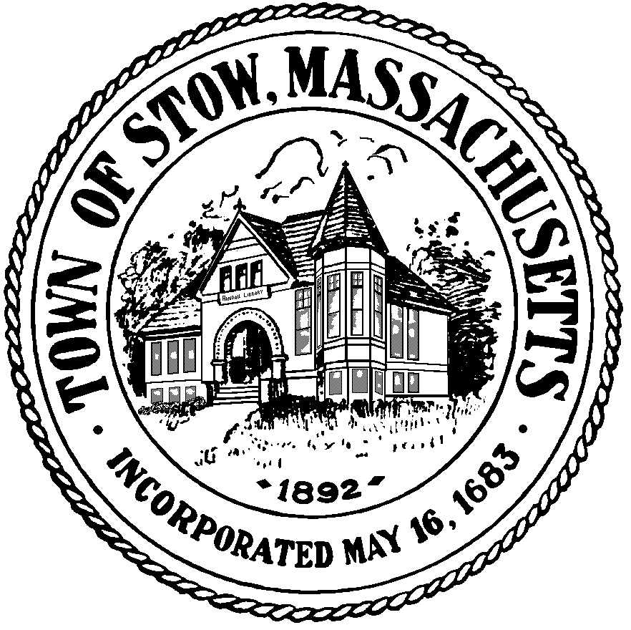

Town of Stow
Finance Committee

Town Building - 380 Great Road
Stow, Massachusetts 01775-2127
(978) 897-4514 x 1
FAX (978) 897-4534

Approved
Minutes
October 11, 2016

Members Present:
Peter McManus, Chair (PM)
Werner Fritz (WF)
Paul McLaughlin (PL)
Julianne North (JN)

Others Present:
Kathleen Farrell, Administrative Assistant
David Walrath, Town Moderator (DW)
Atli Thorarensen

Call to Order: 7:30pm

Reserve Fund Transfer Requests - none

Discuss Membership
Appointed by the Town Moderator and sworn in by Town Clerk, the Finance Committee Welcomed Julianne North as a voting member
Accounts Payable
7:33pm PM moved to approve Massachusetts Association of Town Finance Committees Annual Dues, WF second, Unanimous support
Review Minutes
7:43pm WF moved to accept the minutes of July 12 2016 as written, PM second. Unanimous support
7:44pm WF moved to approve minutes of August 8, 2016 as amended, JN second. Unanimous support
Liaison Reports
PM reported on Randall Library renovations. Using CPC funds to restore historic part of library and plan to have proposal ready for Annual Town Meeting
Other Business
General discussion about Special Town Meeting 8/8/16

8:42pm Meeting adjourned

