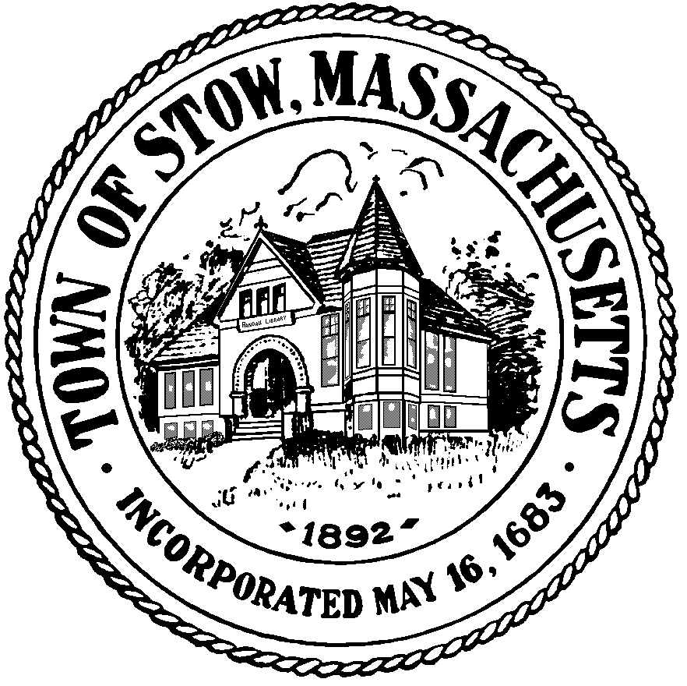

Town of Stow
Finance Committee

Town Building - 380 Great Road
Stow, Massachusetts 01775-2127
(978) 897-4514 x 1
FAX (978) 897-4534

Agenda
Town Building

December 13, 2016
7:30 pm

- Call to Order
- Reserve fund transfer request(s)
- Mail/Correspondence
- Accounts Payable – Finance Committee bills
- Liaison Reports
8:15pm Mark Jones, Nashoba Regional SC
- Review Minutes of 11/22/16
- Other business
- Adjourn

