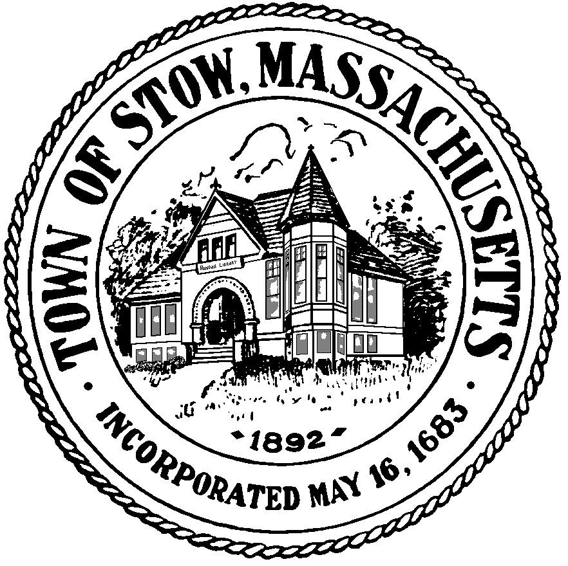

Town of Stow

community preservation committee

Agenda for Monday, May 23, 2011 7:30pm, Town Building
- BILLS & MINUTES
- ELECTIONS FOR OFFICES
- STONE BUILDING DISCUSSION
- COMMUNITY PRESERVATION PLAN DISCUSSION
- Parcel U-7 #34 DISCUSSION
- HISTORIC FAÇADE DISCUSSION
- UPDATE ON CURRENT PROJECTS
- POTENTIAL NEW PROJECTS
- NEWS & VIEWS

